Your Title: Lorem Ipsum
Author A (presenter)^{1,*}, Author B^{1,2}, Author C², …, and Author Z^{n}
1 – Laboratory of Improbable science, University of Nowhere, Somewhere, MyCountry
2 – Laboratory of less probable findings, University in the Middle, Nowhere, AnotherCountry
…
n – Institute for n studies, University of Infinite Research, Whoknowswhere, ANthCountry

* Presenting author: author.a@anemail.com
Abstract
This is the bulk of the abstract. Length should not exceed one page. The abstract will not be published online but will be made available to participants of the workshop.
The venue can easily be reached using public transportation. Geneva International Airport (GVA Cointrin) is the closest airport. The total travel time from Geneva airport to Villars by direct train is 2.5 hours, including one short transfer stop.
The workshop series on ultrafast laser modifications of materials is organized by a group of scientists as an informal gathering for presenting recent progress and exchanging ideas in the vibrant field of ultrafast laser-matter interaction with the sole purpose of advancing scientific knowledge.
The format of the workshop is a focused single session, featuring a series of high-profile invited talks as well as opportunities for students and young scientists to present their works in a dedicated poster and short presentation session. It is meant to provide an inspiring environment and set up to promote exchanges and foster collaborations.
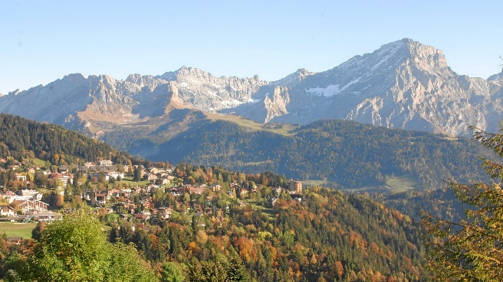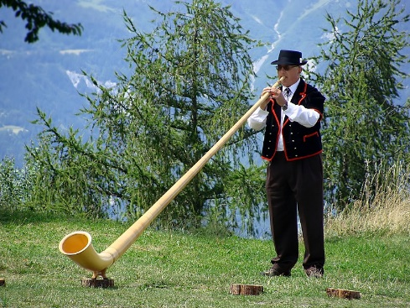
- In case you would like to add a Figure, here is an example of possible format. Yodelei, yodelei, … The beautiful landcape around Villars (a) and an Alpine horn (b).
From WikiPedia: ‘The alphorn (German: Alphorn, Alpenhorn; French: cor des Alpes; Italian: corno alpino) is a traditional lip-reed wind instrument. It consists of a very long straight wooden natural horn, with a length of 3 to 4 metres (9.8 to 13 feet), a conical bore and a wooden cup-shaped mouthpiece.
Traditionally the alphorn was made in one piece from the trunk of a pine.[1] Modern alphorns are usually made in three detachable sections for easier transport and handling, carved from blocks of spruce.[2] The alphorn is used by rural communities in the Alps. Similar wooden horns were used for communication in most mountainous regions of Europe, from the Alps to the Carpathians.’ [2]
References
- Campbell, Murray (2019). "Alphorn". In Trevor Herbert; Arnold Myers; John Wallace (eds.). The Cambridge Encyclopedia of Brass Instruments. Cambridge: Cambridge University Press. p.18-20. doi:10.1017/9781316841273.
- "The Making Of An Alphorn". www.nendazcordesalpes.ch/en. Valais drink pure. Archived from the original on 29 October 2021. Retrieved 13 October 2021.
- In general, we suggest to use Optica’s publications format for the references.

